2020 Long Range World Record Attempt
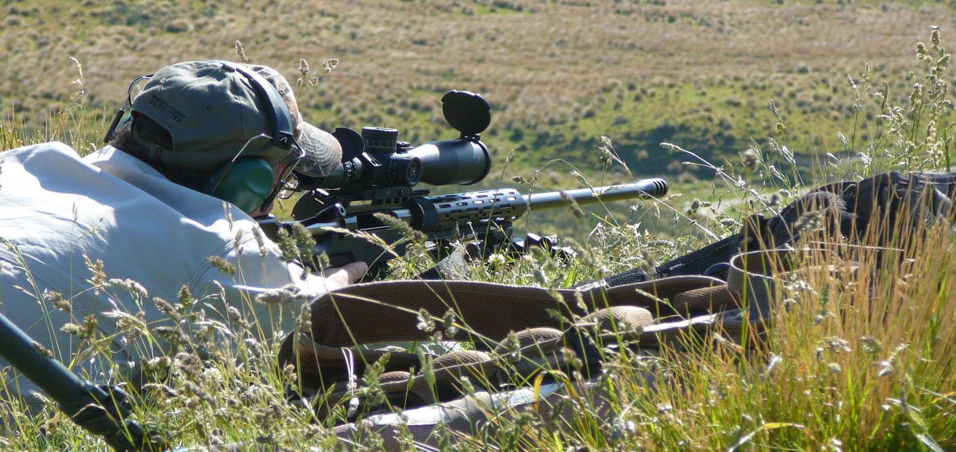
Where: Located in the hills behind Albury,15min from Fairlie, 45 min from Timaru.
When: 26-28 June 2020.
Prep times: Range will be available by prior arrangement only.
Cost: $200
Bring own food or BACKCOUNTRY dehydrated meals can be provided by prior arrangement.

This Event will be conducted over three days to allow for adverse weather conditions. The event will be conducted under ELR Central rules for world record criteria. A copy of these rules is available on the sparrowhawk website or can be made available on request.

Two Classes for Entry : Standard (current record 2158 yards/1973 meters)
22 Long Rifle (Current record 440 Yards/402 meters)
To qualify as a new record, Any existing record must be broken by at least 10 yards

Competition briefing each day will be at sunrise, this must be attended by all competitors to maintain required witnesses.
Firearms licence to be presented before shooting is allowed.

Onsite accommodation may be available with basic shepherds hut style quarters. Please ring to check availability at $15 per night.
You are welcome to camp on the range with own camping equipment or the nearest accommodation is the Albury Inn 13km down the road. Phone 03 6855 910 to enquire.
Everyone present will be required to sign a release, discharge, indemnity form at the first briefing prior to match commencement. A copy of which, for information purposes, can be found on the website.

Event limited to 30 shooters. Confirmation of entry on receipt of payment.

For further details or to register please check our website or contact:
Nick Fisher on 021 166 6843
Email: admin@sparrowhawk.co.nz

