2020 Teams Long Rifle Challenge
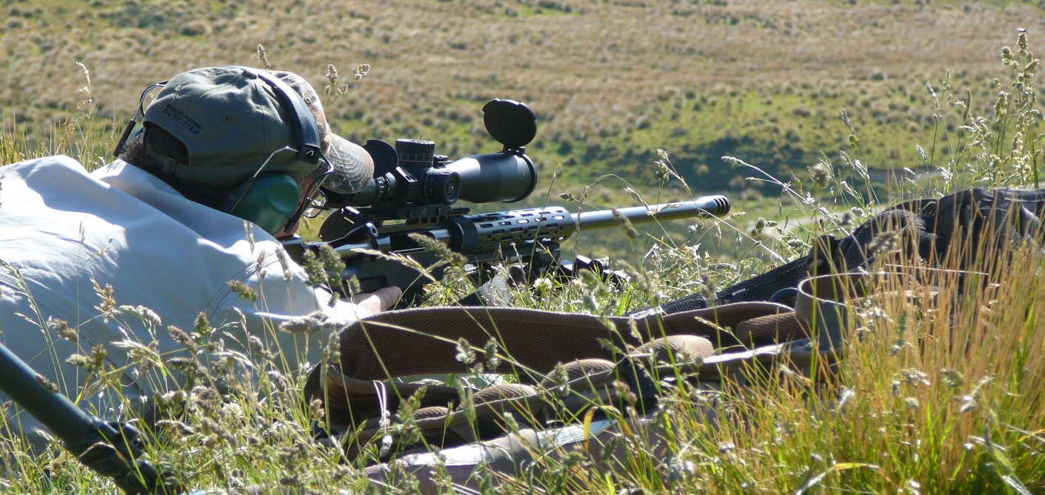
Where: Located in the hills behind Albury,15min from Fairlie, 45 min from Timaru.
When: 8-9 August 2020.
Zero: 7 August from 1200 – 1600hrs
Cost: $400 per team of two
Meals: BBQ lunch provided. Please advise of any dietary requirements.

This Challenge will consist of a Team vs Team competition followed by a number of shooting problems.

There will be prone and non-prone shooting including the opportunity to use shooting aides (You will need to provide own shooting aides e.g. shooting sticks/bags). The course of fire is suitable for all fitness levels. Each shooter will need to carry own equipment (but not far).
August around here usually means snow, frost or mud so 4WD access only onto ranges and plenty of warm gears.
The shoot will go on regardless of inclement but not serious weather however there is plenty of time set aside for standing around the campfire keeping warm.

There will be a range available Friday afternoon to zero your rifle, (no other time is available) practice range has 100m on paper and 200-400m on steel.
Any calibre welcome however absolutely no steel core, carbide or other hardened penetrator/projectiles.

Competition briefing each day will be 8.30 am,
Firearms licence to be presented before shooting is allowed.

Shepherds hut style onsite accommodation available on request at $15 per night for up to 10 people. you are welcome to pitch a tent as well if you are brave enough.
Everyone present will be required to sign a release, discharge, indemnity form at the first briefing prior to match commencement. A copy of which, for information purposes, can be found on the website

Competition limited to 15 Teams. Confirmation of entry on receipt of payment.

To order a registration form use the email at the bottom of this page:
Nick Fisher on 021 166 6843
Email: admin@sparrowhawk.co.nz

STLRC 2020 Entry Form

TEAM NAME________________________________________________
Team member 1
Name _______________________________________________________________

Address __________________________________________________________

Email Phone _______________________________________________________________
Class: Magnum Non Magnum

Dietary requirements/ Food Allergies. ____________________

Team member 2
Name _______________________________________________________________

Address __________________________________________________________

Email Phone _______________________________________________________________
Class: Magnum Non Magnum

Dietary requirements/ Food Allergies. ____________________

Payment details:
Sparrowhawknz
ASB 12-3228-0050905-00
With your name as reference

Please email or post this form back to details below:
Sparrowhawk
398 Blainslie Road
RD17 Fairlie, 7987
or email admin@sparrowhawk.co.nz

